Inserting Citations
CMI Style Guide (Turabian/Chicago)
- Click on the “Reference” tab at the top
- Look for the Insert Citation icon. Next to it you will see “Style:” Use the drop down arrow to select Chicago

- Place your cursor where the citation needs to be added. (See circle below)
Jack Deere, in The Bible Knowledge Commentary, explains the necessity of intensely teaching children so as to insure the continuation of a relationship with the Lord from generation to generation: "Only by letting God's words invade every area of their lives and homes and by diligently teaching them to their children could the nation hope to escape the seduction of false worship”

- Click “Insert Citation”
Choose “Add new source”—This will bring up a box with fields you can enter the appropriate information for the citation.

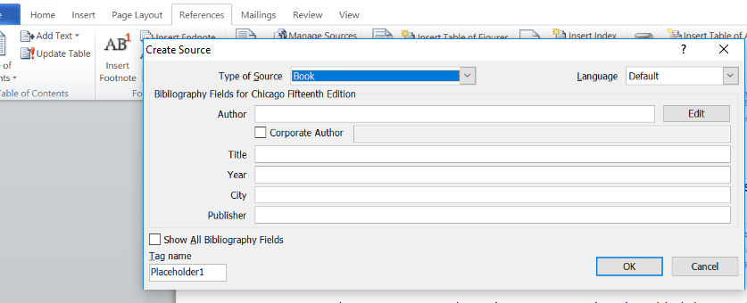
- Choose the “Type of Source” (highlighted in blue above). Use the arrow to choose which type of source you are citing. It will then bring up the main information points that should be included in that particular type of citation. After completing the information, click “OK.”

It will save the information which will be used in your Bibliography OR if you are using the same source again.

Jack Deere, in The Bible Knowledge Commentary, explains the necessity of intensely teaching children so as to insure the continuation of a relationship with the Lord from generation to generation: "Only by letting God's words invade every area of their lives and homes and by diligently teaching them to their children could the nation hope to escape the seduction of false worship” (Walvoord and Zuck 1985).
- After the author(s) name and year of publication are inserted in the document, click on the name to insert the page number(s). The box will turn gray and give you another drop down box. Click on the arrow to insert the page numbers.
- Click “OK”
Jack Deere, in The Bible Knowledge Commentary, explains the necessity of intensely teaching children so as to insure the continuation of a relationship with the Lord from generation to generation: "Only by letting God's words invade every area of their lives and homes and by diligently teaching them to their children could the nation hope to escape the seduction of false worship” (Walvoord and Zuck 1985, 282-283).

If you need to edit a source because it has not displayed the information properly, you will choose edit source rather than edit citation.

- Each time you add a new source, Word will retain the information. If you re-use a book or site, you will simply go to the “reference tab” then “insert citation” and look for the book that has been saved. You will need to put in the correct page number.
CREATING A BIBLIOGRAPHY
- When you have completed your paper, place your cursor on the top of the final page of your paper.
- Click on the reference tab, then click on the Bibliography arrow
- Choose “Bibliography” and it will automatically insert every reference used in alphabetical order.

Bibliography
Walvoord, John, and Roy B. Zuck. 1985. The Bible Knowledge Commentary. Colorado Springs: Cook Communications. WORDsearch CROSS e-book.

